**Ex: 4**

**Date:** 14/10/2020

**Aim:**

To create a program to swap first two alphabets of a two given string then check the condition of the string whether it is of length greater than 2 or display invalid.

**Program:**

def s(a,b):

t= b[:2] + a[2:]

v= a[:2] + b[2:]

return t+' '+v

st=str(input()).strip()

sv=str(input()).strip()

if(len(st)<2 or len(sv)<2):

print("Invalid")

else:

print(s(st,sv))

**Output:**

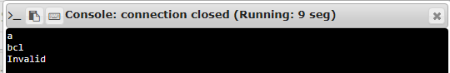

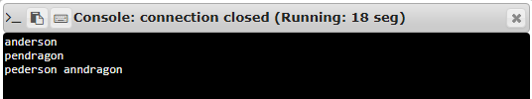

**Result:**

Thus, creating a python program to swap first two alphabets of given two string and checking the condition of string is greater than two or display invalid is done.

**Link:**

<http://103.53.53.18/mod/vpl/forms/submissionview.php?id=234&userid=1652>